IN 43
ELECTRONIC ICU BED, 4 MOTORS
- Electrical operated backrest, height and legrest adjustment
- Electrical operated Trendelenburg, Reverse Trendelenburg, fowler and vascular position
- Patient handset
- Foot end nurse control unit
- Control panels embedded on side rails; 2 for patient; 2 for nursing staff
- Footrest adjustment by ratchet
- Auto-CPR
- Auto Regression system on backrest
- Auto contour
- Hygienic design (PP), lockable and tuck away side rails
- Easy removable ABS mattress platform
- X-Ray Translucent Backrest with Cassette Holder
- Removable head and footboards
- Electrostatic epoxy painted metal frame
- Height adjustable stainless steel IV pole
- Plastic protective crash bumpers on four corners
- Central Lockable Castors, 150 mm
- Angle indicator for backrest
- Angle indicator for Trendelenburg and Reverse Trendelenburg positions
- Cardiac chair position with single button
- Shock position with single button
- Semi-Fowler position with single button
- Bed exit position with single button
- Examination position with single button
- Electronic CPR with single button
- Activation key at remote control to prevent any undesired positions
- Dual sided manual CPR levers at backrest
- Stationary headboard
- Urine bag holder
- Rechargeable Battery Backup
- Bed size extension (optional)
- IPX6 standard electronic system
Other icu bed products
 | TECHNICAL DETAILS
 | Overall Length: 223 cm | Castor Diameter: 15 cm
 | Overall Width: 102 cm | Under Bed Clearance: 15 cm
 | Height Range: 42-84 cm | Safe Working Load: 250 kg
 | Trendelenburg : 0°-16° | Power In: 1.5A max. At 230V AC 50-60 Hz
 | Reverse Trendelenburg: 0°-16° | Electrical Shock Protection: Class I, Type B
 | Backrest Angle: 0°-70° | Liquid Ingress Protection: IPX6
 | Legrest Angle: 0°-35° | Batteries: 2x 12V Series Connected, sealed, rechargeable, Lead / Acid gel,1.2 amp hrs.

ACCESSORIES
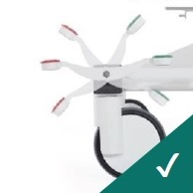
Central Brake Castors 150 mm
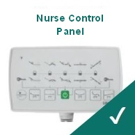
Foot-end Nurse Control Panel
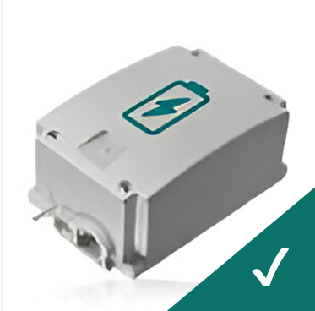
Rechargeable Battery Backup
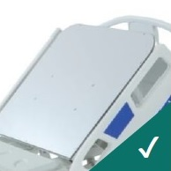
X-Ray Translucent Backrest with Cassette Holder
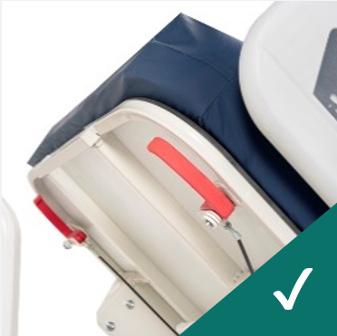
Dual Sided Manual CPR at Backrest
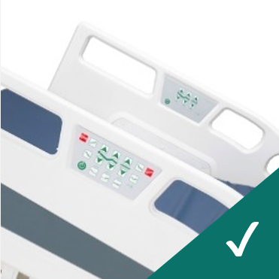
Control Panels Embedded on Side Rails
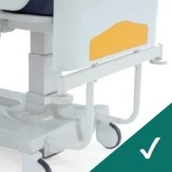
Stationary Headboard
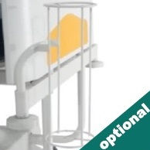
Oxygen Cylinder Holder
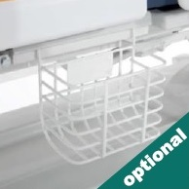
Urine Bag Basket
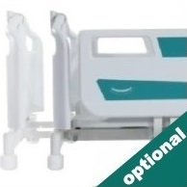
Bed Extension
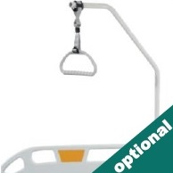
Lifting Pole
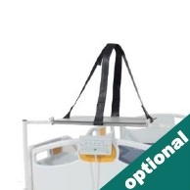
Monitor & Defibrillator Shelf
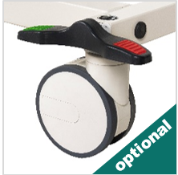
Double Wheels
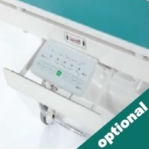
Nurse Panel Shelf
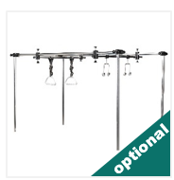
Orthopedic Traction System
COLOR CHART
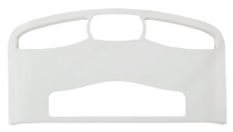
P01
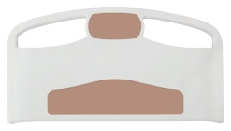
P02
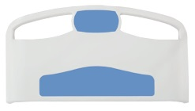
P03
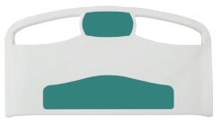
P04
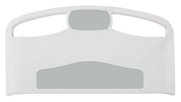
P05
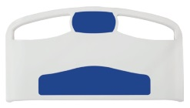
P06
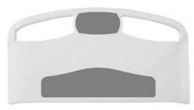
P07
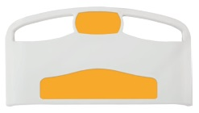
P08

